**[DOING PHYSICS WITH PYTHON](https://d-arora.github.io/Doing-Physics-With-Matlab/)**

**COMPUTATIONAL OPTICS**

**RAYLEIGH-SOMMERFELD 1**

**DIFFRACTION INTEGRAL:**

**BESSEL BEAM PROPAGATION**

**FROM A CIRCULAR APERTURE**

**Ian Cooper**

Please email me any corrections, comments, suggestions or additions: **matlabvisualphysics@gmail.com**

**DOWNLOAD DIRECTORIES FOR PYTHON CODE**

[**Google drive**](https://drive.google.com/drive/u/3/folders/1j09aAhfrVYpiMavajrgSvUMc89ksF9Jb)

[**GitHub**](https://github.com/D-Arora/Doing-Physics-With-Matlab/tree/master/python)

**emRSBessel01.py** Irradiance: XY planes: *IXY*

**emRSBessel02.py** Irradiance: optical axis: *IZ*

**emRSBessel03.py** Irradiance: ZX planes: *IZX*

**INTRODUCTION**

The [**Rayleigh-Sommerfeld diffraction integral of the first kind**](https://d-arora.github.io/Doing-Physics-With-Matlab/pyDocs/emRS01.pdf) is used to calculate the intensity of a **Bessel beam** diffracted by a circular aperture.

The geometry of the aperture and observation spaces is shown in figure 1 and figure 2 shows an outline of how to the RS1 diffraction integral is computed in Python.

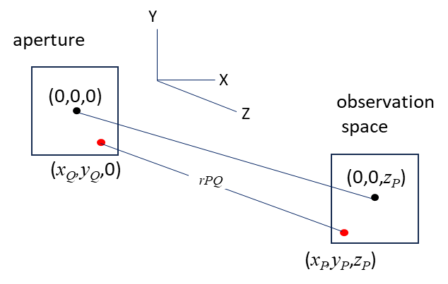

Fig. 1. Geometry of the aperture and observation spaces.

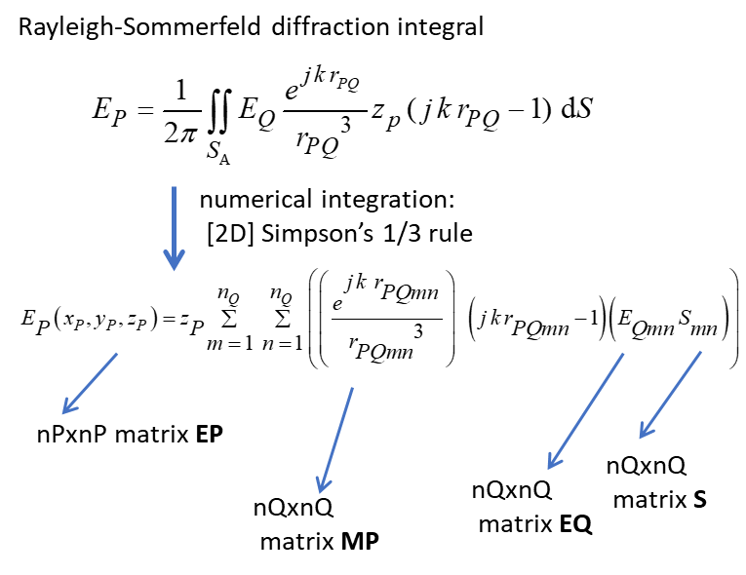

Fig. 2. Matrices used in computed the diffraction integral.

**BESSEL FUNCTIONS**

Diffraction is a cornerstone of optical physics and has implications for the design of all optical systems. This article discusses the so-called ‘non-diffracting’ light field, commonly known as the **Bessel beam**.

Bessel beams are of interest because of their intense central core. The narrow non-diffracting features of the Bessel beam are able to act as atomic guides and atomic confinement devices and optical manipulation, where the reconstruction properties of the beam enable new effects to be observed that cannot be seen with

Gaussian beams. A Bessel beam gets its name from the

description of such a beam using a **Bessel function**, and this

leads to a predicted cross-sectional profile of a set of concentric rings.

The *n*th order **Bessel beam function**  can be computed using a Python function as shown in the following Python Code and figure 1. Non-integer order Bessel beams functions can alos be calculated.

import numpy as np

import matplotlib.pyplot as plt

from scipy.special import jv

plt.rcParams["figure.figsize"] = (6,4)

fig1, ax = plt.subplots(nrows=1, ncols=1)

x = np.linspace(-20, 20, 1000)

for c in range(4):

ax.plot(x, jv(c, x),lw = 2, label=f'$J_{c}$')

ax.legend(fontsize = 10)

ax.grid()

ax.set_xlabel('r', fontsize=12)

ax.set_ylabel('J$_n$(r) ', fontsize=12)

fig1.tight_layout()

fig1.savefig('a1.png')

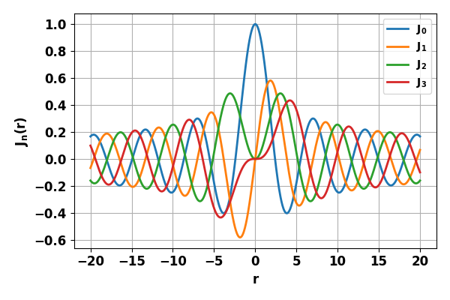

Fig. 1. Bessel functions for orders *n* = 0, 1, 2 ,3.

**SIMULATIONS**

The Python Codes **emBessel01.py, emBessel02.py,** and **emBessel01.py** are used for simulations of the propagation of a Bessel beam from a circular aperture of radius *a*. A Bessel function of order *n* is calculated from 0 to . This array is then scaled from 0 to *a* so that the Bessel function profile fits the radius of the circular aperture. By increasing the value of , more rings will be present within the aperture.

**Bessel function of order 2; *J*2**

**emBessel01.py**

Order Bessel function n = 2

nQ = 199 nP = 237

wavelength wL = 633 nm

aperture radius a = 1.000 mm

zPeak = 0.376 m

Execution time = 166 s

***Aperture space***

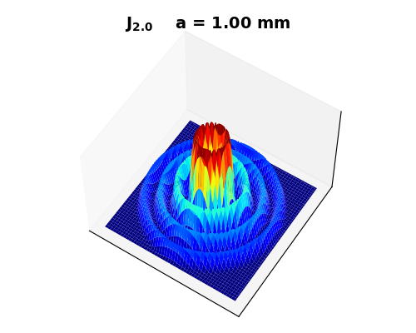

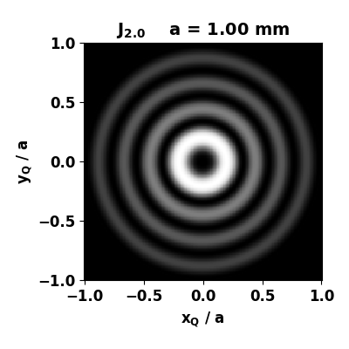

Fig.1A. [3D] and [2D] views of the aperture irradiance where



**emBessel01.py**

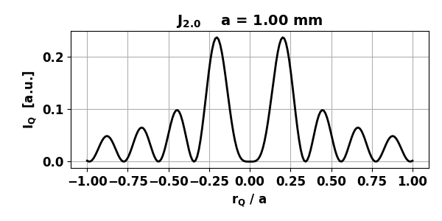

Fig.1B. [1D] radial view of the normalized aperture irradiance where



**emBessel01.py**

***Observation space***

Figure 2 shows [1D] and [2D] views of the normalized irradiance in XY planes for different distances  between the plane of the aperture and the observation plane.

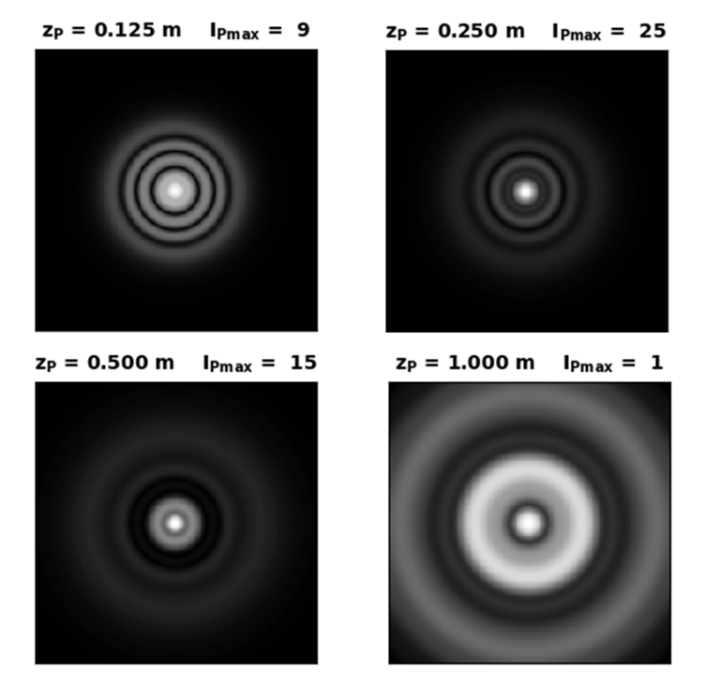

Fig. 2A. Scaled irradiance  in the observation plane for the 2nd order Bessel beam. The scaling of the irradiance enhances the bright rings. The dimension of the observation space is 2*a*x2*a*

(a = 1.00 mm). **emBessel01.py**

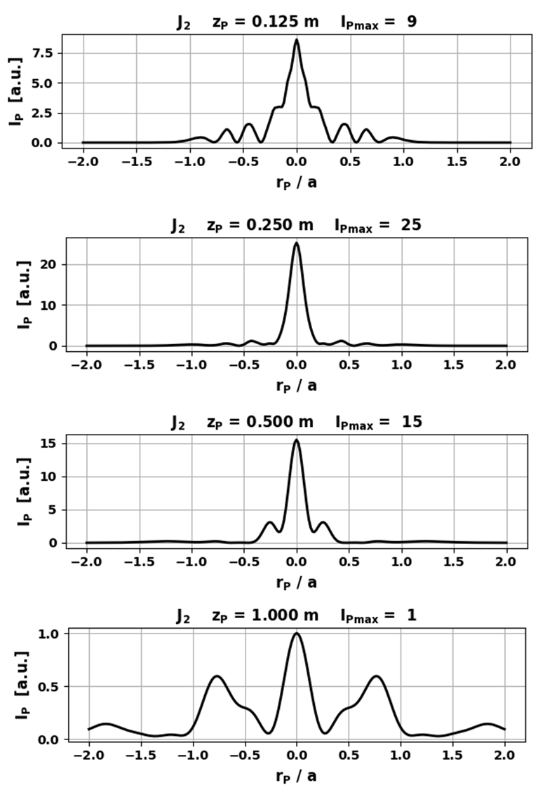

Fig. 2B. [1D] plots of the observation space irradiance for the 2nd order Bessel beam. The irradiance is normalized such that the peak irradiance at *zP* = 1.00m is 1.00 (*a* = 1.00 mm). **emBessel01.py**

The 2nd order Bessel beam is characterized by its unique intensity profile, featuring a central bright spot surrounded by multiple nested circular rings. This beam type exhibits non-diffracting behaviour, that is, the intensity distribution remains relatively constant as it propagates over a limited *z* distance.

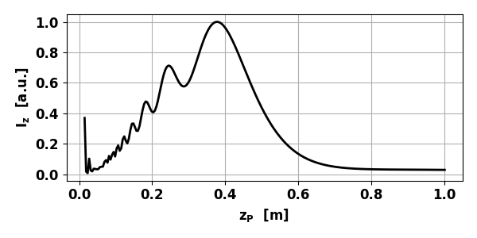

Fig. 3. Variation in the irradiance  along the optical axis.

zPeak = 0.378 m (*a* = 1.00 mm) **emBessel02.py**

For the 2nd order Bessel beam, the irradiance in the central region of the aperture is dark. As you move away from the aperture along the optical axis, the central region gets brighter and brighter until a maximum bright stop occurs at *zP* = 0.378 m, then the central region becomes darker and darker as you move further away from the aperture (figure 3).

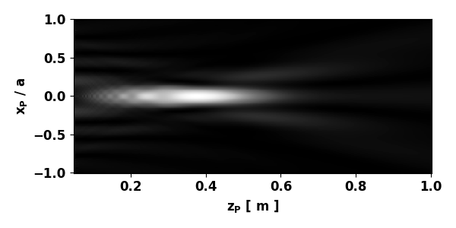

Fig. 4. Irradiance in the ZX plane. (*a* = 1.00 mm)

**emBessel03.py**

**Bessel function of order 1; *J*1**

Order Bessel function n = 1.00

nQ = 199 nP = 237

aperture radius = 1.000 mm

Wavelength wL = 632.8 nm

Execution time 166 s

***Aperture space***

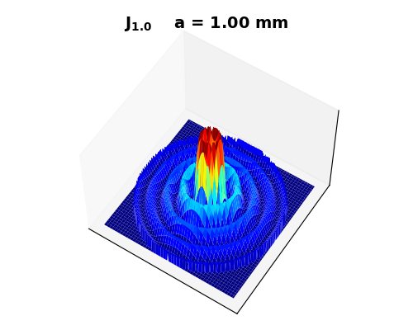

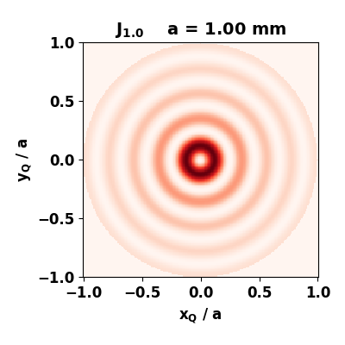

Fig. 5A. [3D] and [2D] views of the aperture irradiance where



**emBessel01.py**

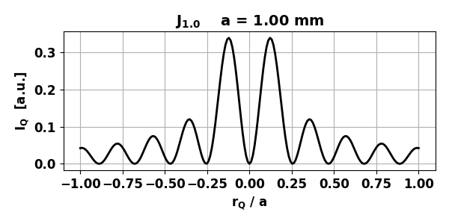

Fig.5B. [1D] radial view of the normalized aperture irradiance where



**emBessel01.py**

***Observation space***

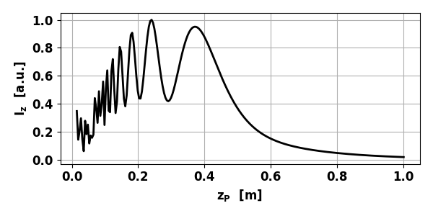

Fig. 6. Variation in the normalized irradiance  along the optical axis. zPeak = 0.240 m (*a* = 1.00 mm) **emBessel02.py**

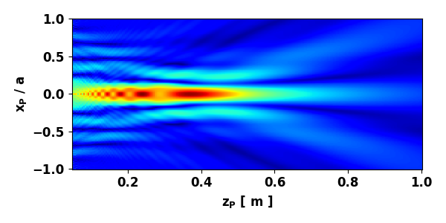

Fig. 7. Scaled irradiance *IZX* in the ZX plane. **emBessel03.py**

Figure 8 shows [1D], [2D] and [3D] views of the scaled irradiance in XY planes for different distances  between the plane of the aperture and the observation plane. The power scaling of the irradiance enhances the bright rings. The dimension of the observation space is 2*a*x2*a.*

The irradiance in the observation XY planes show a very compact bright spot on the optical axis surrounded by a series if weak bright rings.

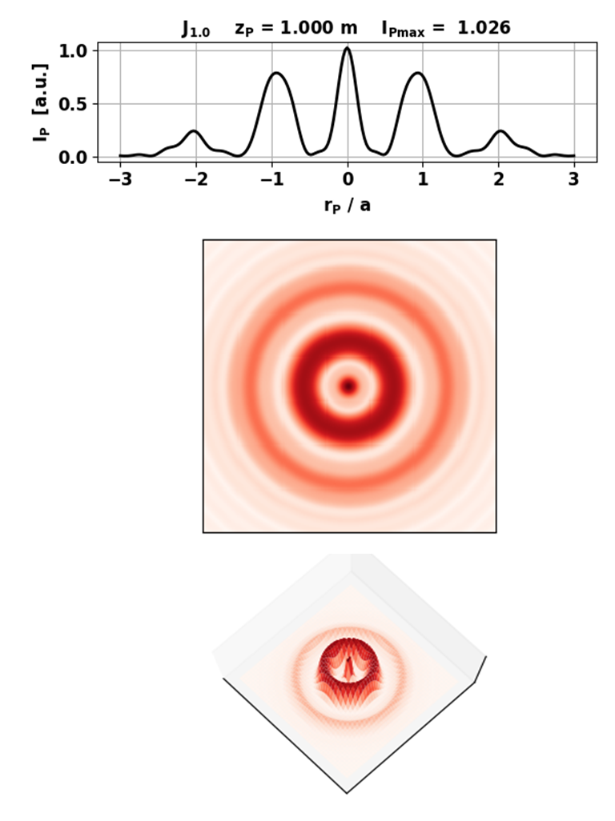

Fig. 8A. Scaled irradiance  in the observation plane for the 1st order Bessel beam where m.

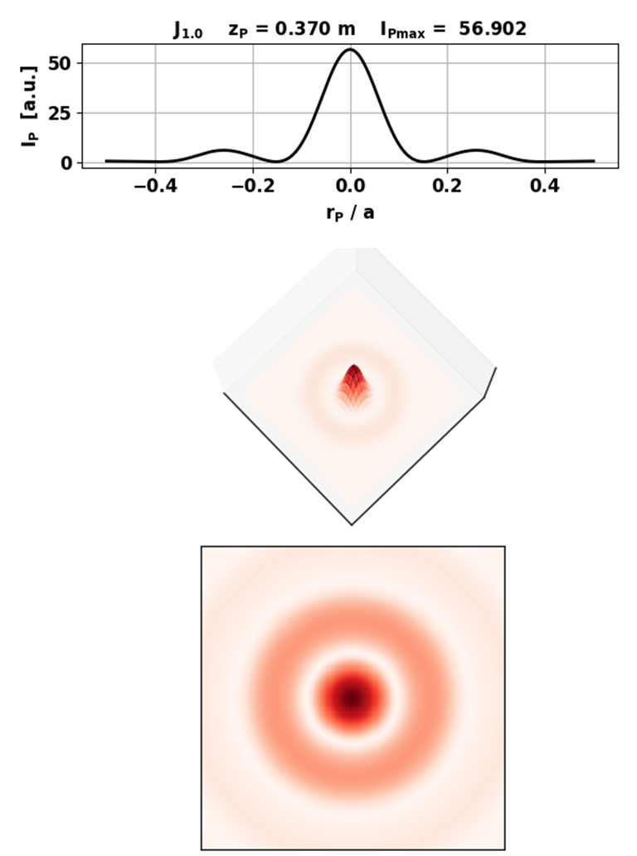

Fig. 8B. Scaled irradiance  in the observation plane for the 1st order Bessel beam where  m.

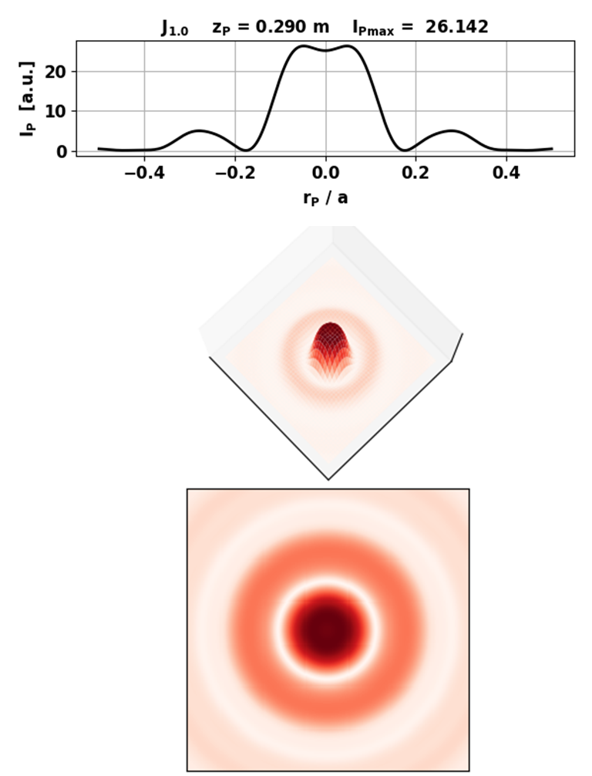

Fig. 8C. Scaled irradiance  in the observation plane for the 1st order Bessel beam where  m.

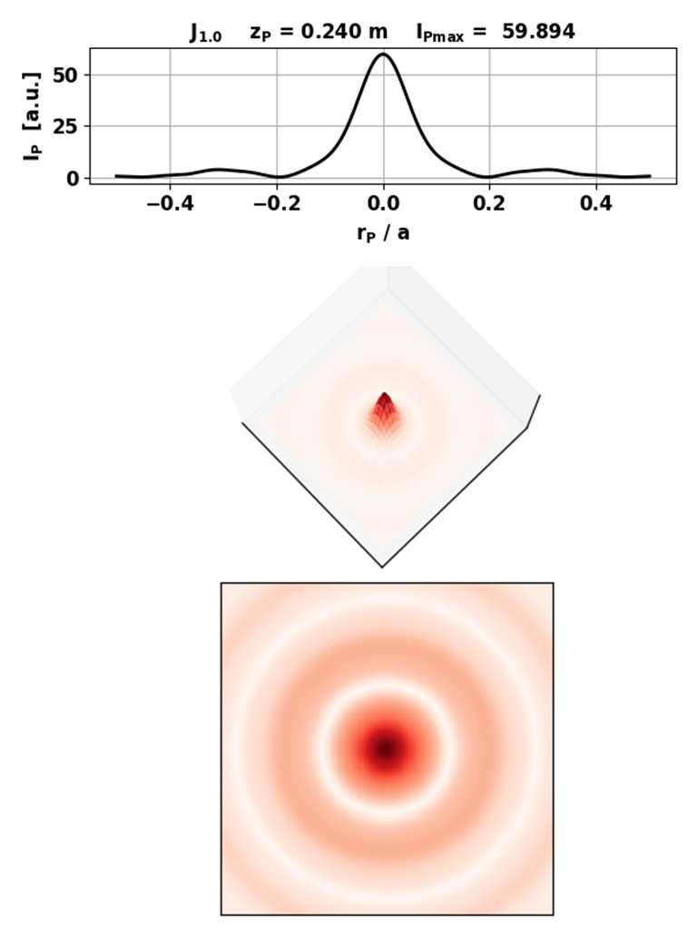

Fig. 8D. Scaled irradiance  in the observation plane for the 1st order Bessel beam where  m.

**Bessel function of order 0; *J*0**

Order Bessel function n = 0

nQ = 199 nP = 237

aperture radius = 1.000 mm

Wavelength wL = 632.8 nm

Execution time 166 s

***Aperture space***

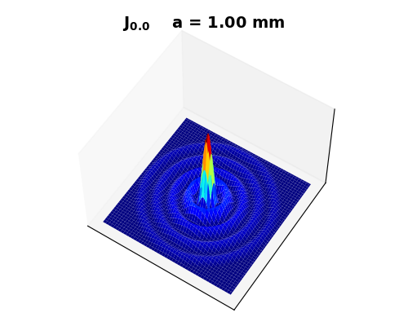

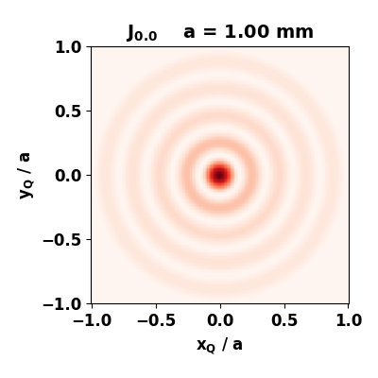

Fig.9A. [3D] and [2D] views of the aperture irradiance where



**emBessel01.py**

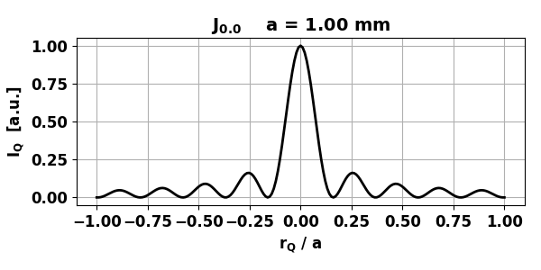

Fig.9B. [1D] radial view of the normalized aperture irradiance where



**emBessel01.py**

***Observation space***

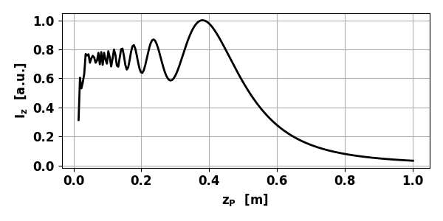

Fig. 10A. Variation in the normalized irradiance  along the optical axis for 0th order Bessel function. zPeak = 0.378 m (*a* = 1.00 mm) **emBessel02**

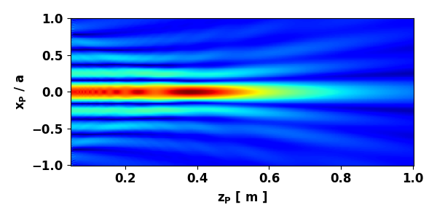

Fig. 10B. Scaled irradiance *IZX* in the ZX plane for 0th order Bessel function. **emBessel03.py**

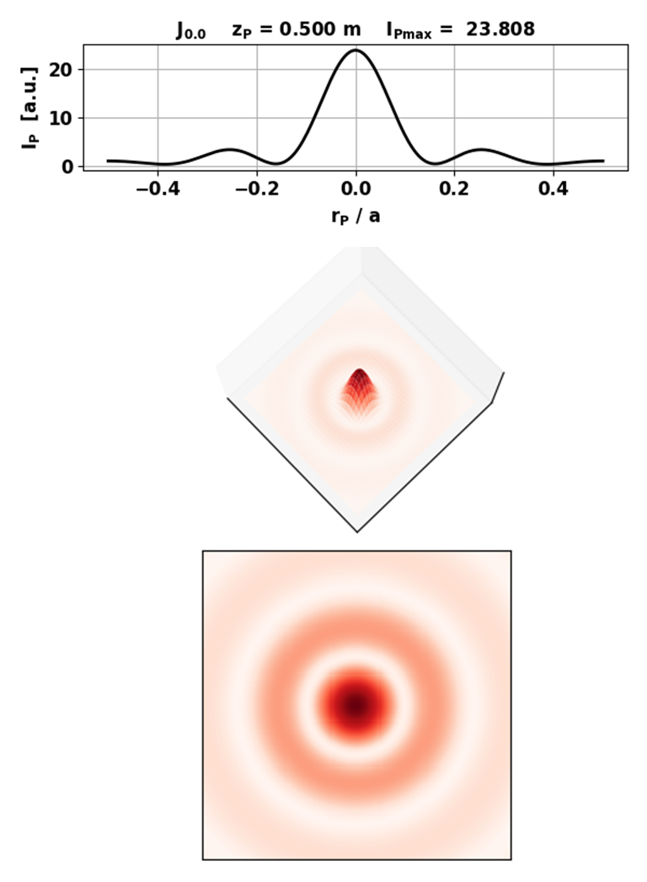

Fig. 11A. Scaled irradiance  in the observation plane for the 0st order Bessel beam where m.

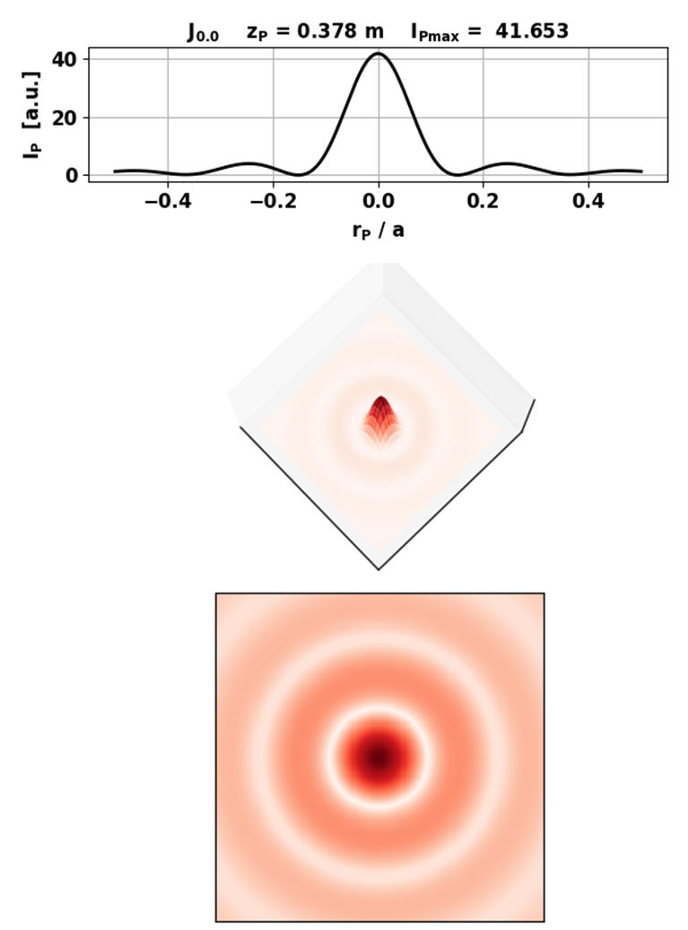

Fig. 11B. Scaled irradiance  in the observation plane for the 1st order Bessel beam where  m.

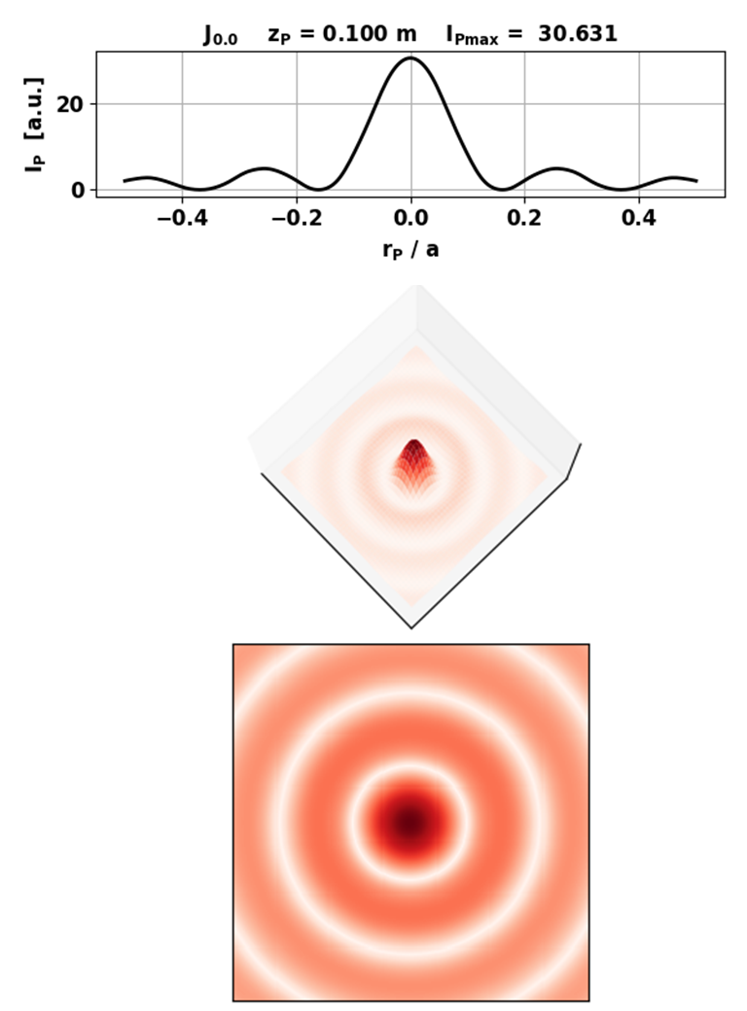

Fig. 11C. Scaled irradiance  in the observation plane for the 0st order Bessel beam where  m.

**Bessel function of order 4.5: *J*4.5**

***Aperture space***

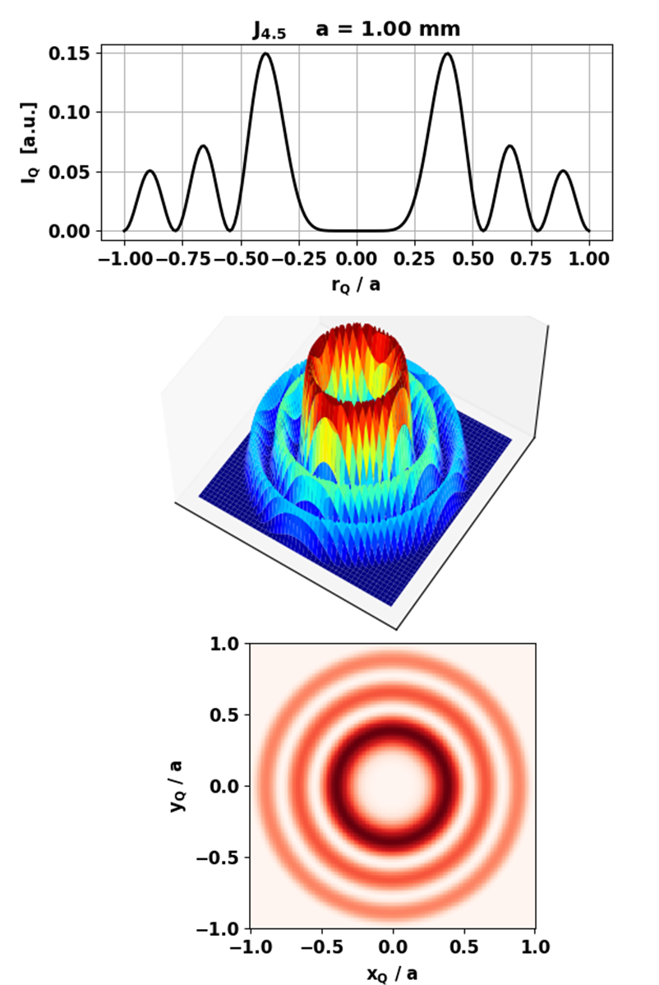

Fig. 12. Aperture space.

Order Bessel funcion n = 4.50

nQ = 199 nP = 237

aperture radius = 1.000 mm

Wavelength wL = 632.8 nm

Execution time 170 s

***Observation space***

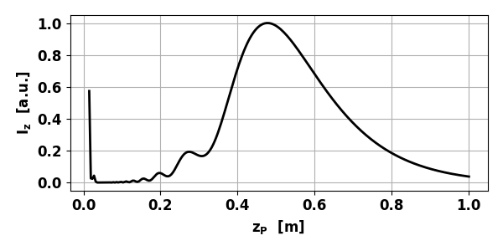

Fig. 13A. Variation in the normalized irradiance  along the optical axis. zPeak = 0.478 m (*a* = 1.00 mm) **emBessel02**

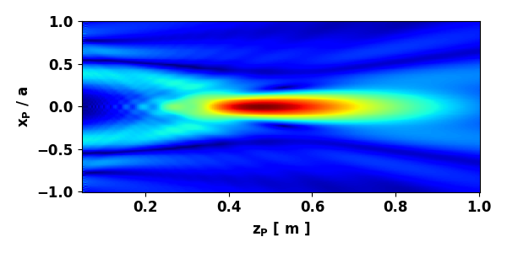

Fig. 13B. Scaled irradiance *IZX* in the ZX plane. **emBessel03**

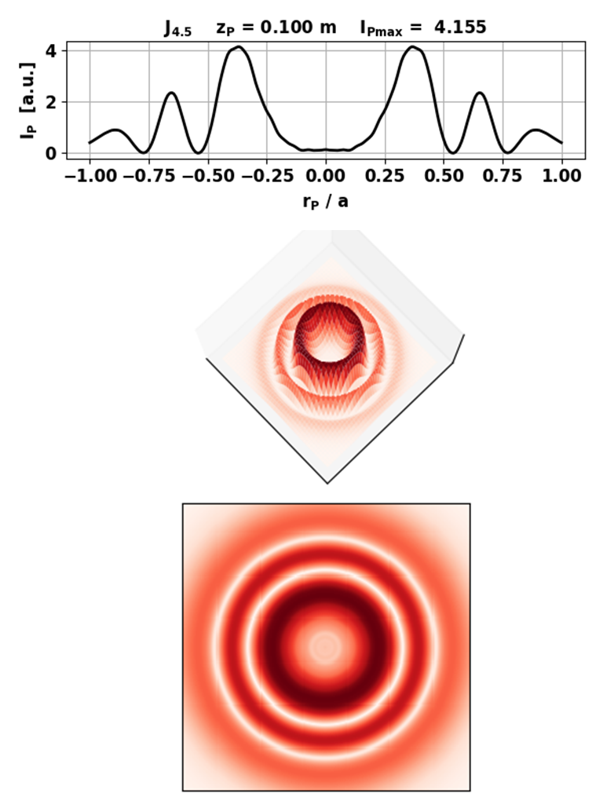

Fig. 14A. Scaled irradiance  in the observation plane for the 0st order Bessel beam where  m.

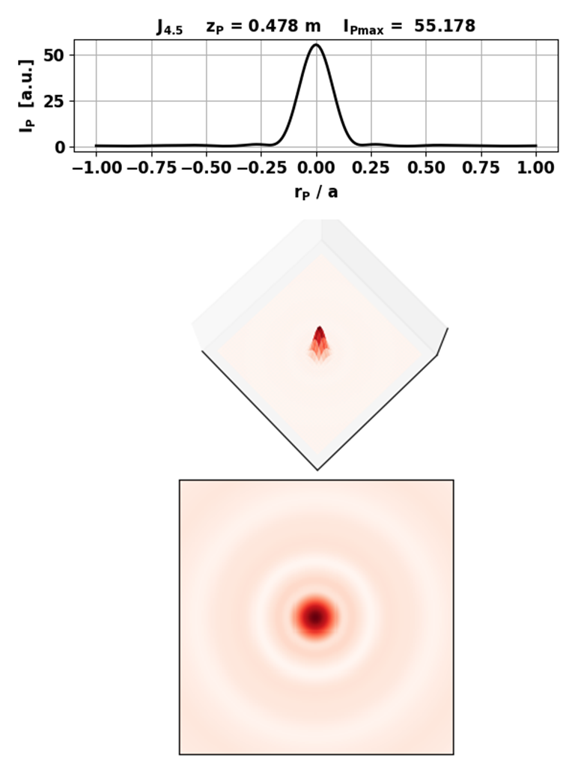

Fig. 14B. Scaled irradiance  in the observation plane for the 0st order Bessel beam where  m.

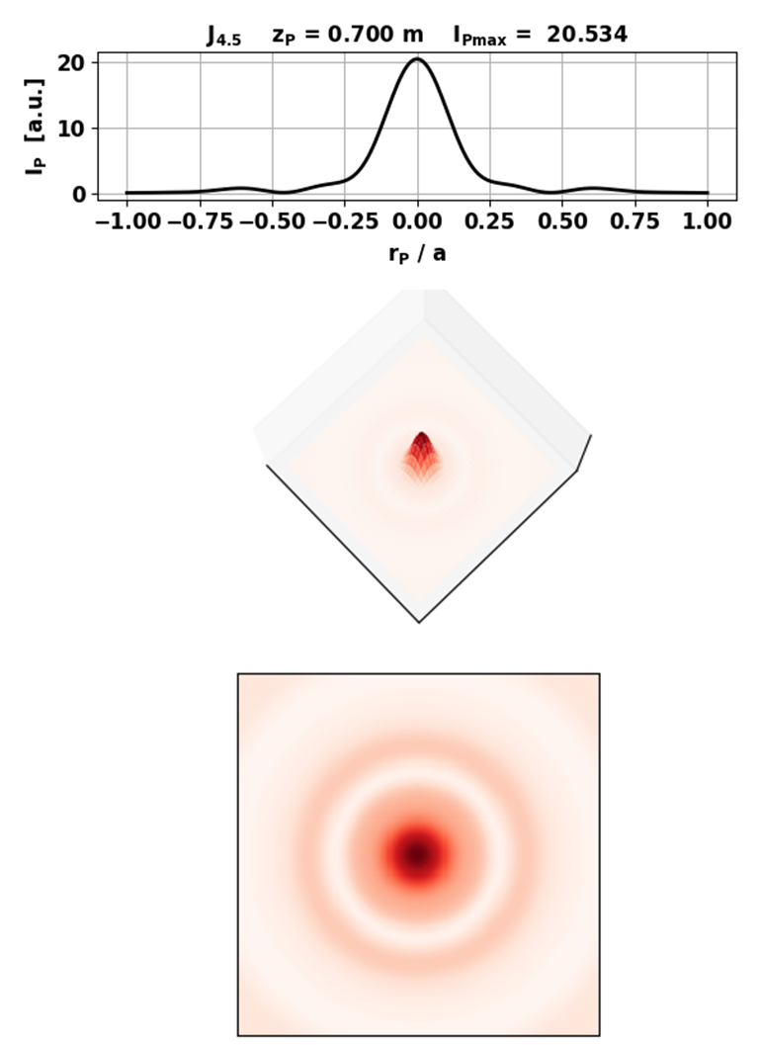

Fig. 14c. Scaled irradiance  in the observation plane for the 0st order Bessel beam where  m.